Computer Vision Homework 1

Name: 黃新予

Student ID: f08922136

Description: I used Anaconda jupyter to complete this homework.

Using Numpy and PIL to store and address every pixel.

Part 1: just exchange the order of corresponding pixel.

Part 2: call functions in PIL.

1. (a) upside-down lena.bmp  
   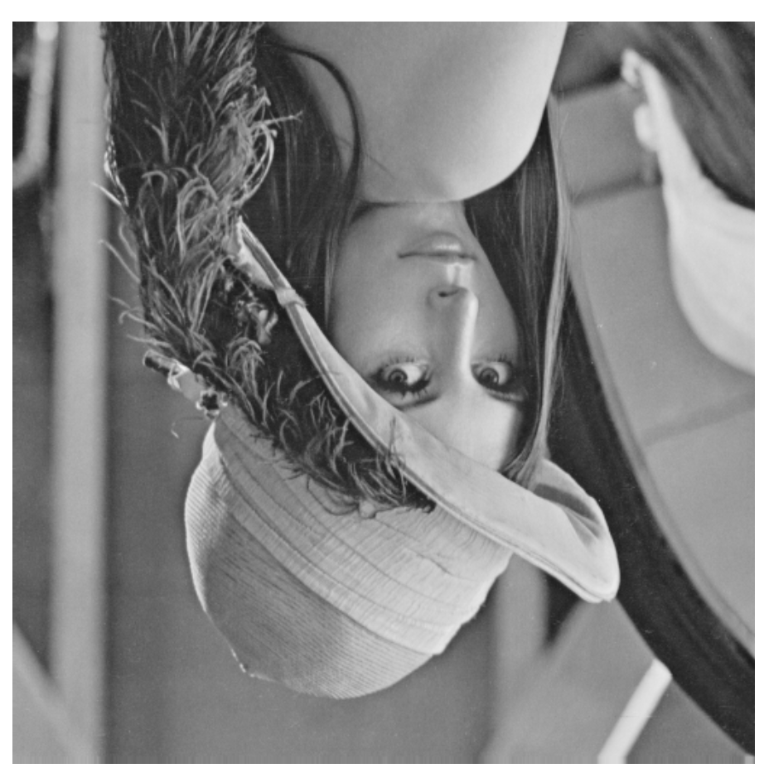  
   Code:  
   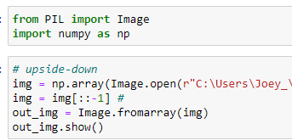  
   (b) right-side-left lena.bmp  
   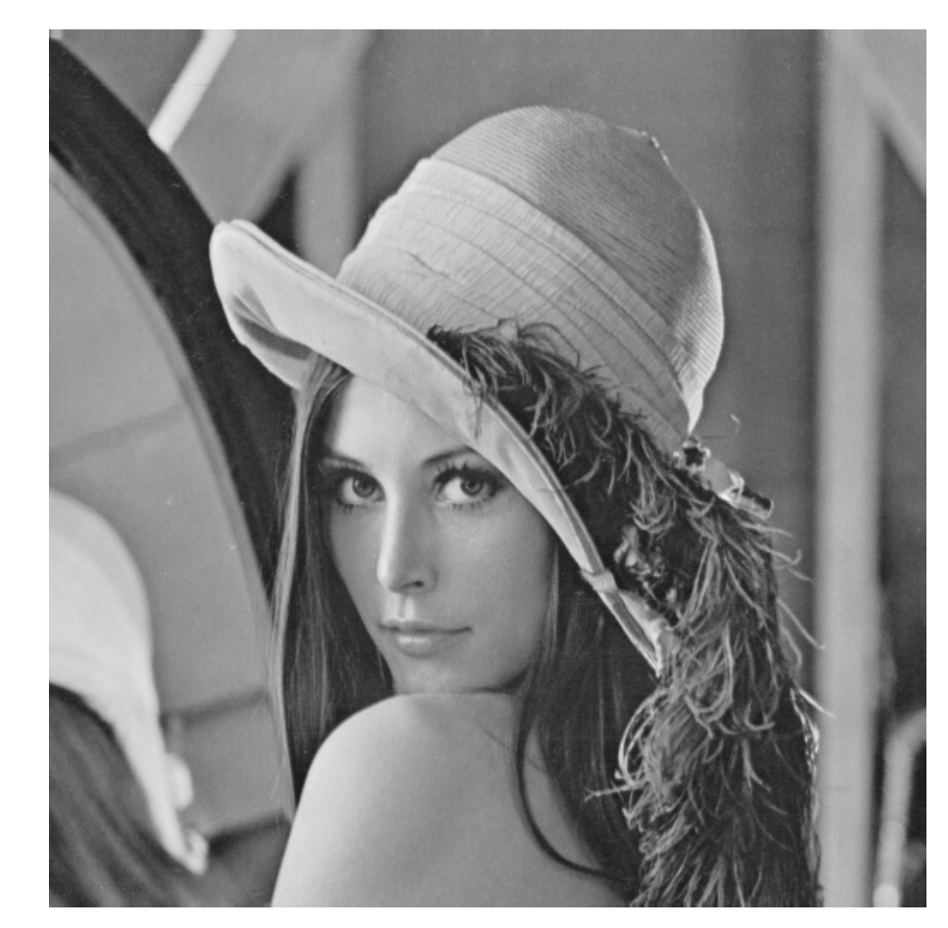  
   Code:

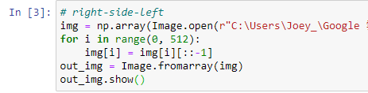

(c) diagonally flip lena.bmp  
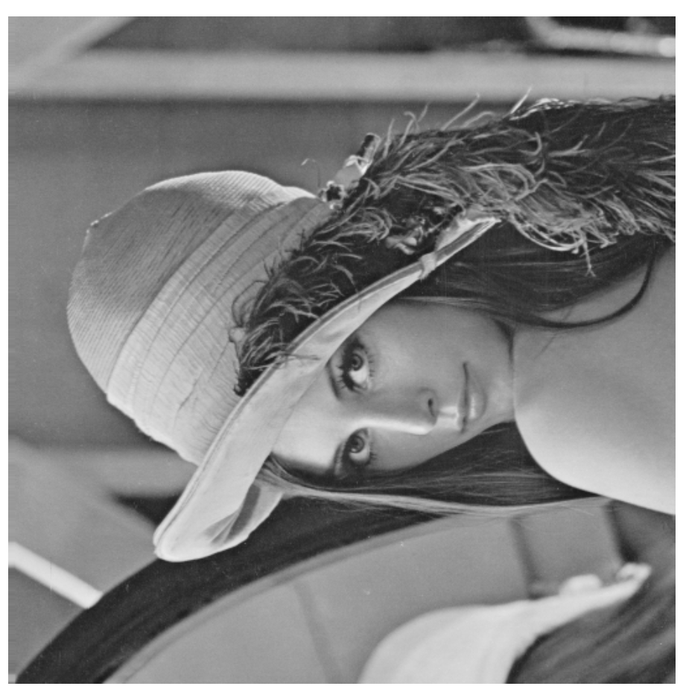  
Code:

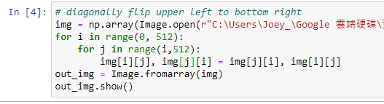

1. (d) rotate lena.bmp 45 degrees clockwise  
   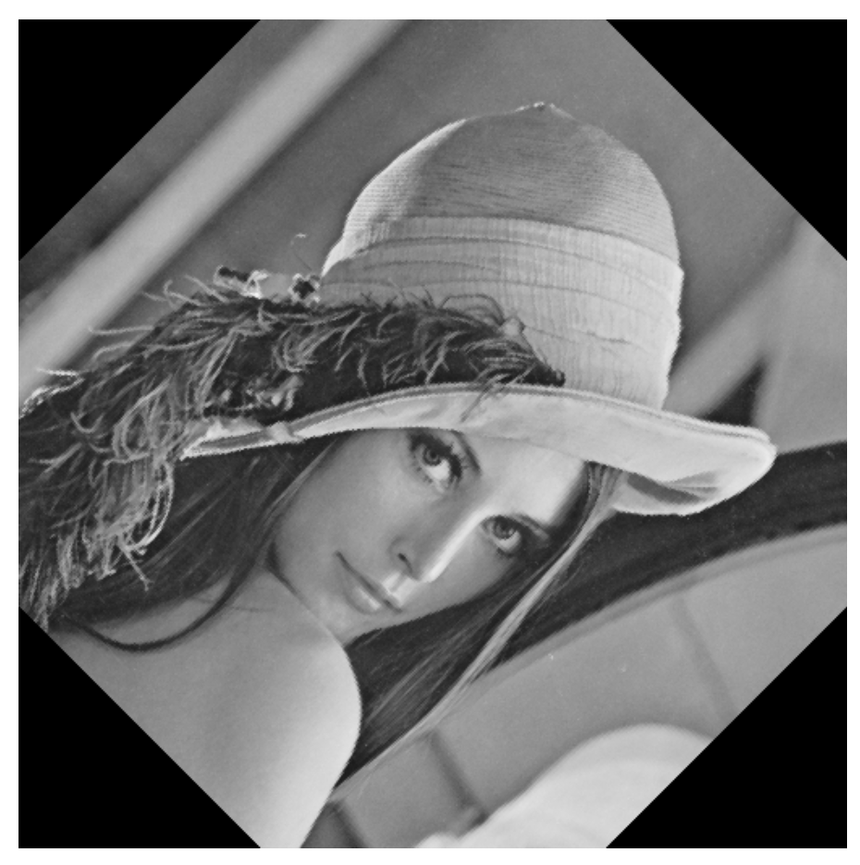  
   Code:  
   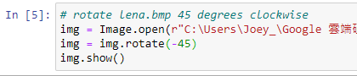

(e) shrink lena.bmp in half  
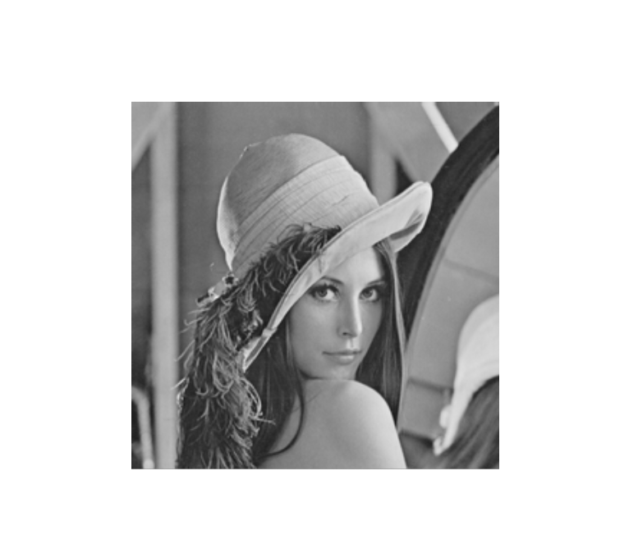  
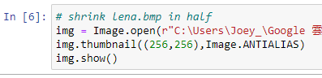

(f) binarize lena.bmp at 128 to get a binary image  
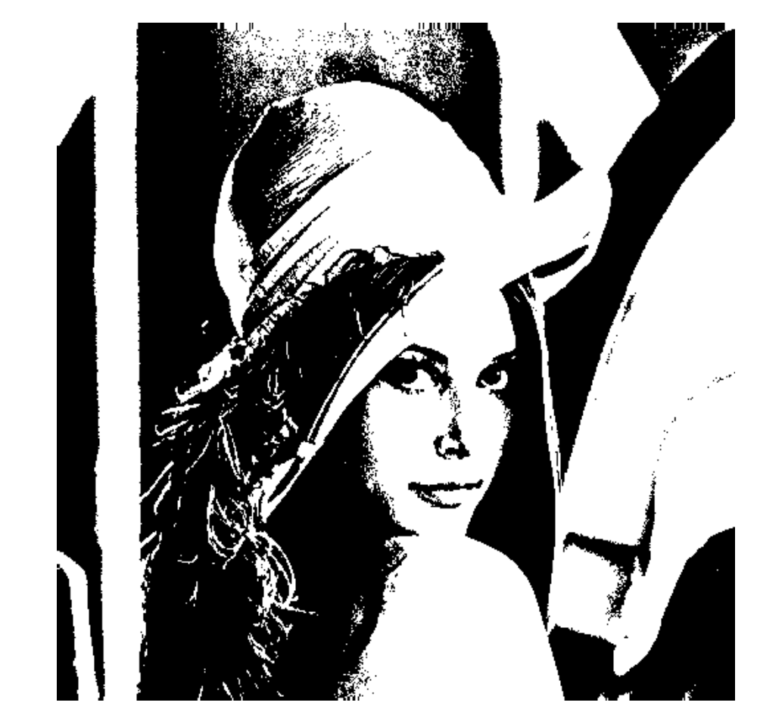  
Code:

